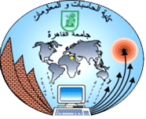

Cairo University
Faculty of Computers and Information
Department of Computer Science

Intelligent Mobile Bus Ticketing System

Supervised by
Dr. Ahmed Shawky Moussa
TA. Mahmoud Mohsen

Implemented by
20140192 | Amr Saeed Hosny
20140064 | Ashrakat Mokhtar
20140187 | Omar Fawzy Salama
20140196 | Amr Magdy Ibrahim

Academic Year 2017-2018
Midyear Documentation of Graduation Project
Abstract
The issue of fast, safe, and non-distracting payment method is very paramount in any transportation, especially if it affects the safety of passengers. Therefore, an efficient solution has to be applied to enforce the separation of driving the vehicle and issuing tickets responsibilities.
Our solution intends to replace old-fashioned methods of issuing tickets by an efficient digital system that falls under the realm of internet of things (IoT). A software application is downloaded on the passenger’s smartphone. Every passenger can have an account on that application containing his/her information. The passenger’s account can be charged with a predetermined amount of balance specified by the passenger at anytime and anyplace. Once enough balance is charged on the account, the passenger can ride any transportation that provides our digital service. The transportation contains an attached IoT device in which passenger can pass his/her smartphone over. That IoT device works as a reader to check passenger’s balance against the transportation ticket price. After the process of validation, the IoT device communicates with a back-end server which in turn sends a digital ticket to passenger’s account and deducts the price of the ticket from the current balance. At this moment, the passenger has a digital ticket on his/her smartphone containing the necessary details that work as a proof of payment.
The tools used to implement our solution are Android, PHP Laravel framework, MySQL database, and Near Field Communication technology (NFC). Android is used as a front-end technology representing the mobile application downloaded on the passenger’s smartphone. NFC technology is used in both smartphones and the IoT device mentioned earlier as a way of communication between them. Modern smarphones come with NFC component which is mostly attached to their back. The IoT device device consists of a board which is connected to NFC component. PHP Laravel is used as back-end server framework representing the implementation of our services. PHP Laravel communicates with MySQL database to store and retrieve passengers’ data.

Work plan
Completed
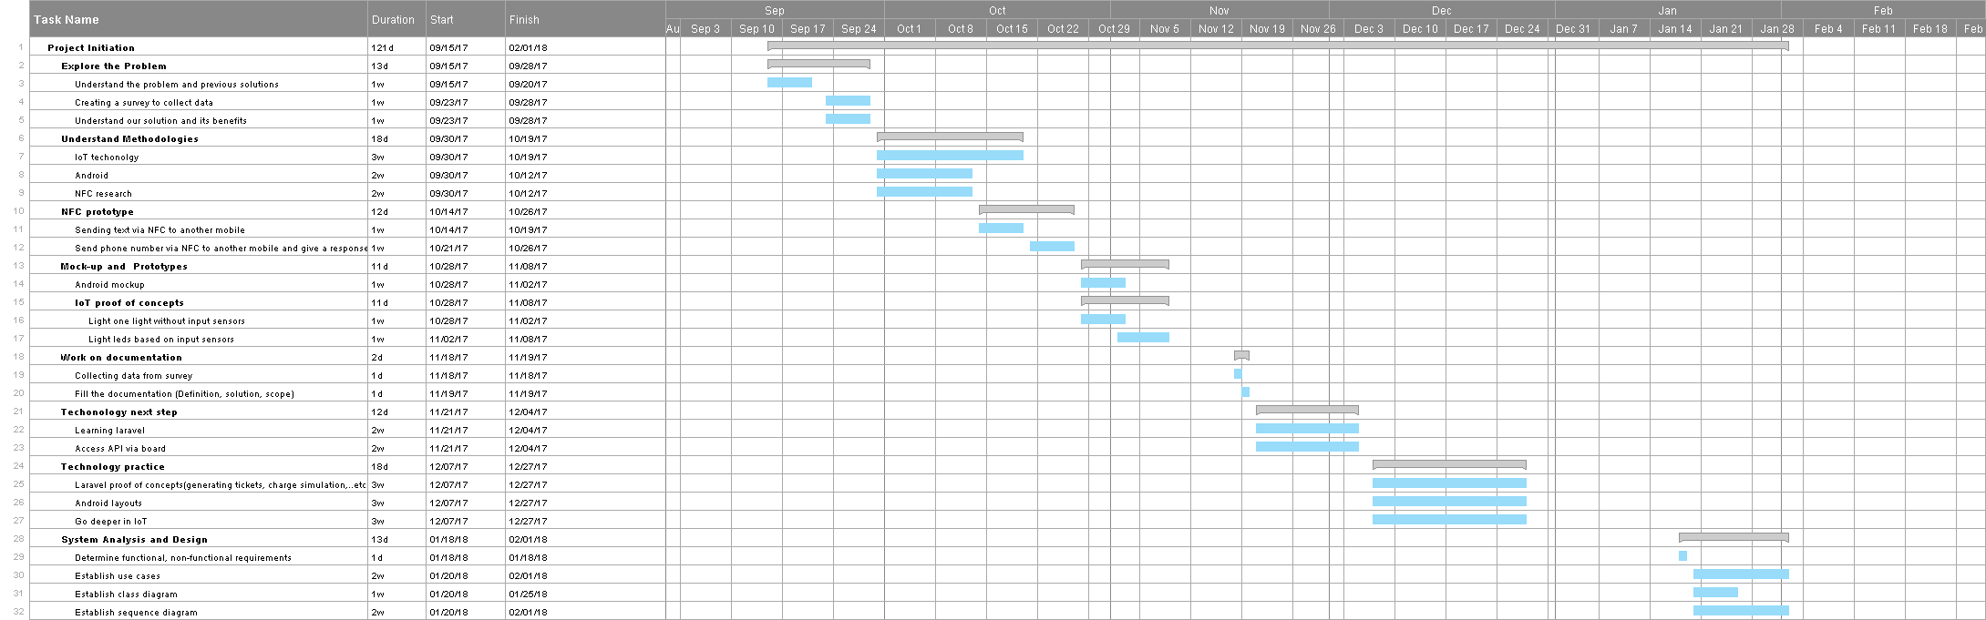
Expected

